**LABLE ENCODING AND ONE HOT ENCODING**

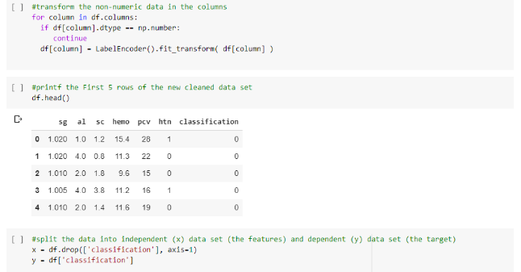

**FEATURE SCALING**

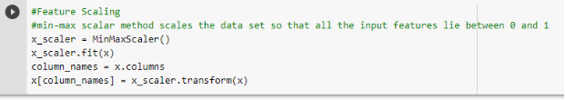

**SPLITTING DATA INTO TRAIN AND TEST**

